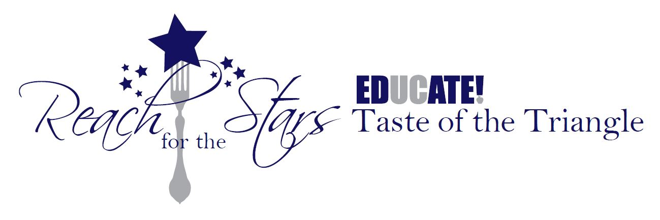

April 30th, 2015
Dear Esteemed Guests of the 21st Annual Taste of the Triangle,
The excitement has reached a fever pitch and we are anxious to get to the UCSD Faculty Club this Saturday Night! We will be featuring electronic bidding this year for auction items. We ask that you register for the silent auction prior to attending the event. Here are the instructions.
All bidding will be done through your cell phone, computer or by “personal shopper” at the event! (Note: you do not need a cell phone to participate in the auction). You can bid from anywhere, anytime before the close of the auction, from your own device! You even get an update if you are outbid!
Here are the details:
- The auction is hosted by ABC
- It’s online now: https://myab.co/events/Hj/
Click on the provided link, register for the event, view the items and begin BIDDING!
- After you register you will get a welcome text message. There are 4 ways to bid:
  - By Smartphone - click the link in your registration text. It will take you to a personal bidding page. Click on an item and place a bid, it’s that simple.
  - By Text - text the 3-digit item number and amount to the welcome message you receive, (i.e. 101 500), no dollar signs or decimals are needed.
  - By “Personal Shopper” at the event- find an ABC staff member in RED. They will be happy to place your bids for you.
  - By Computer- click on an item and place a bid.
Please don't hesitate to contact us at the email address below should you have any questions between now and the event.

We can't wait to see you there!

With great anticipation,
Jemma Samala, Taste of the Triangle Chairperson

